Dominique White
Linux and Virtualization Tech
Professor Monica Fyfe
Sunday, October 5, 2025

Module 6 - Part 2: Hands-On Assignment - Linux Scripting Exercises
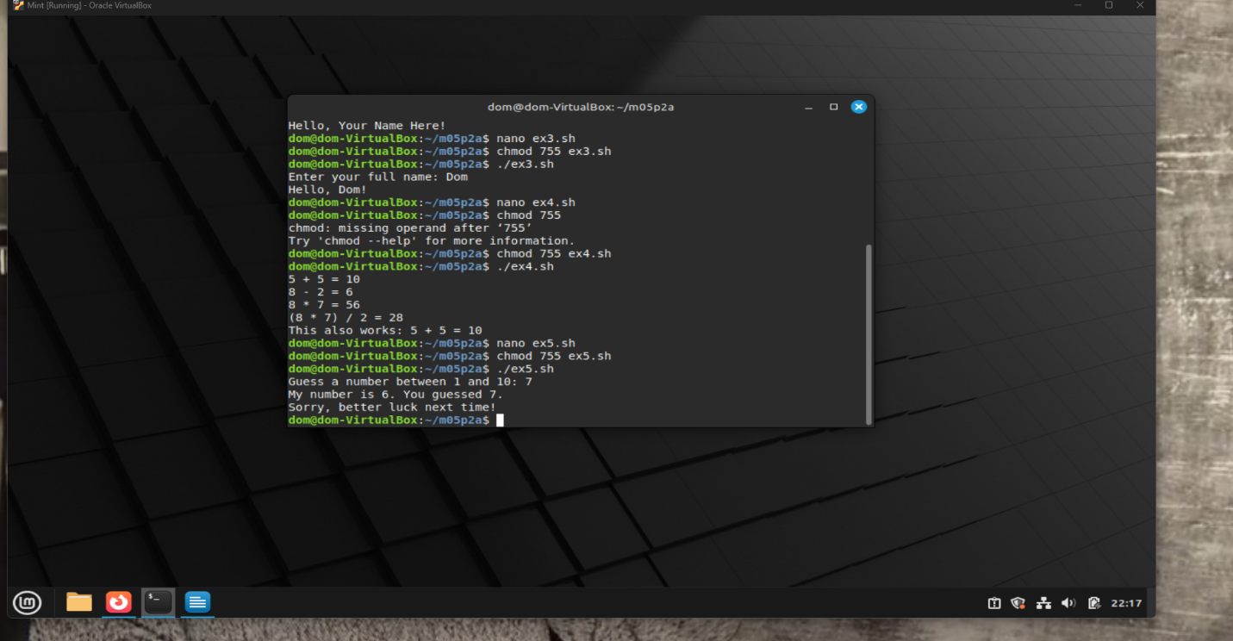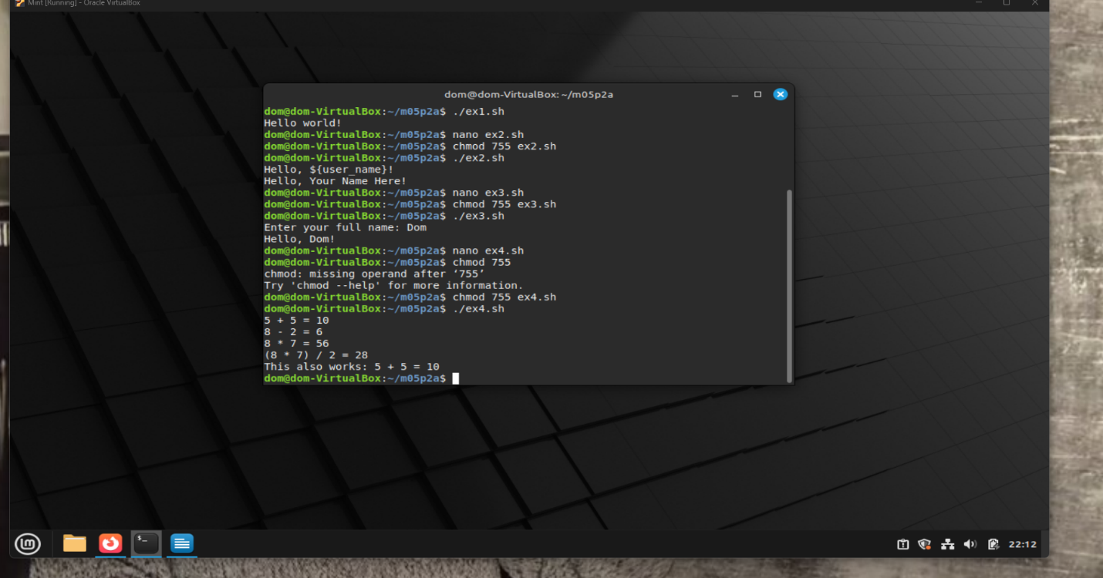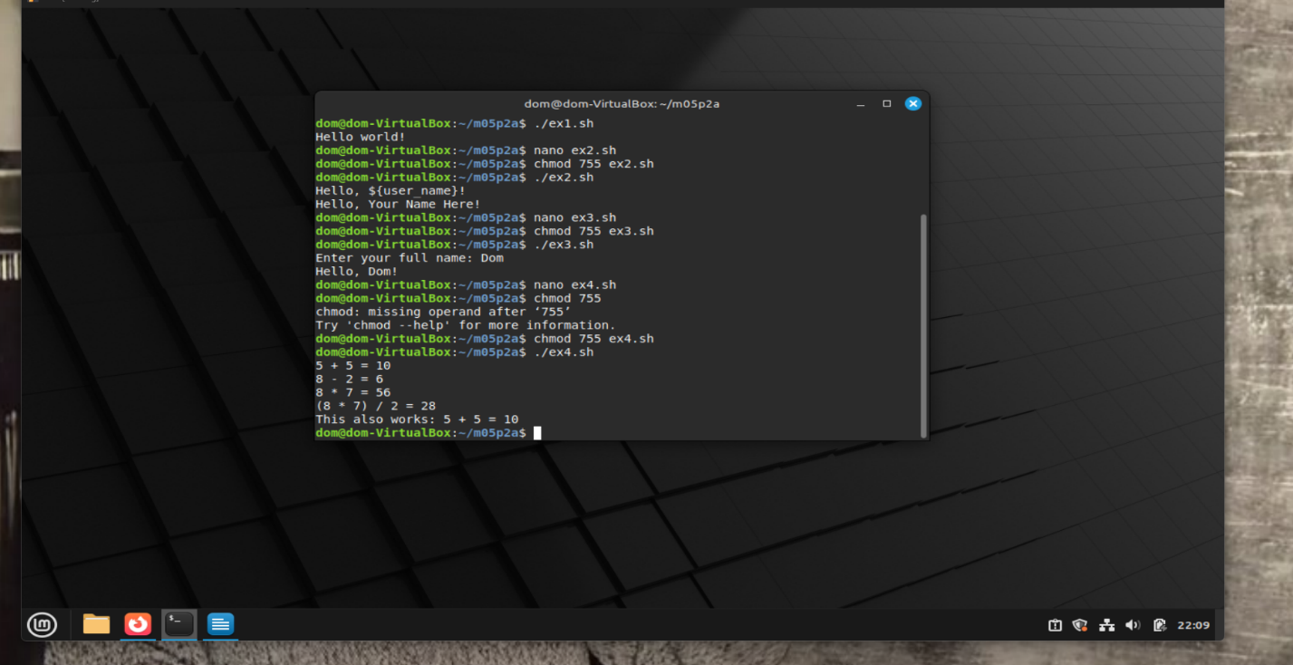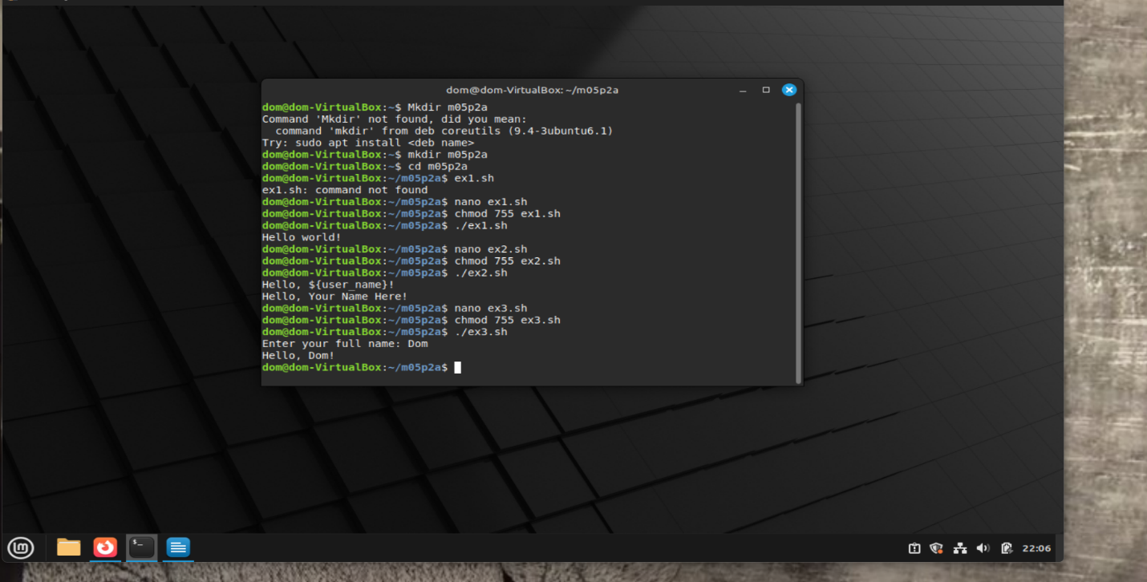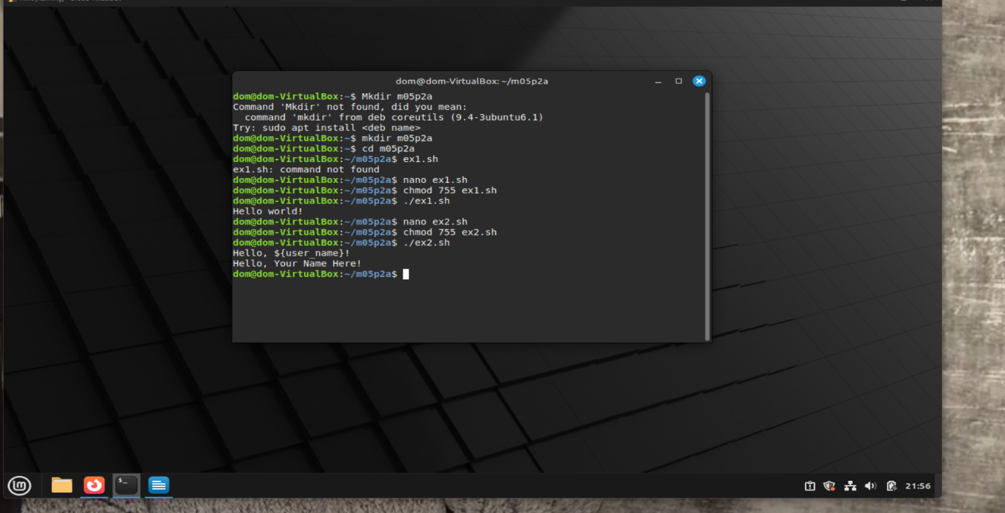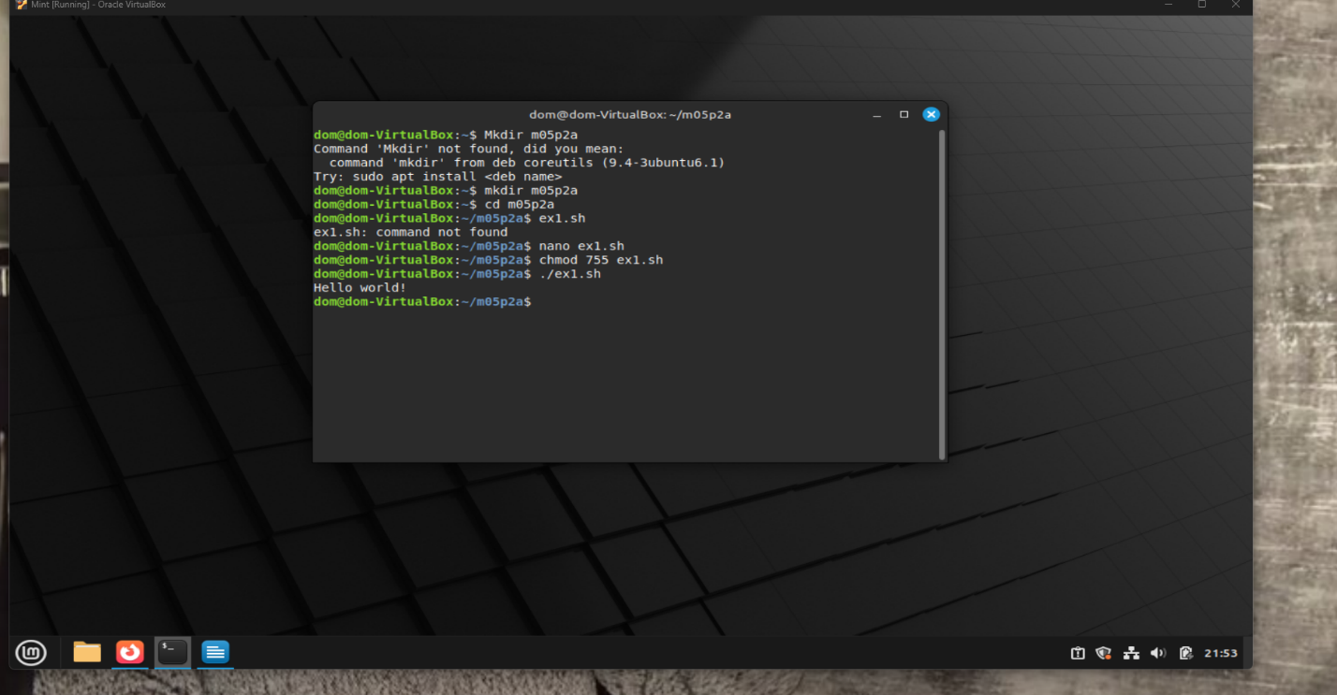

The first line will literally print Hello, ${user_name}! because single quotes prevent variable expansion.
The second line will correctly print Hello, Your Name Here! because double quotes allow variable expansion.
Difference between the two echo lines:
'Hello, ${user_name}!' → prints the string as-is.
"Hello, ${user_name}!" → expands the variable and prints the actual value.
When to use single vs. double quotes:
Use single quotes when you want to print the literal string without interpreting variables.
Use double quotes when you want variables to be expanded.
Question:
What does -n do in echo -n?
It prevents a newline after the prompt, so the user input appears on the same line.
Question:
How to change the range to 51–100?
To change the range of numbers in your guessing game from 1–10 to 51–100, you need to adjust two key values in your script: the minimum and maximum numbers. Set the minimum number to 51 and the maximum number to 100. Then, calculate the range by subtracting the minimum from the maximum and adding one. This gives you the total number of possible values. Finally, use that range to generate a random number and shift it up by the minimum value so it falls within the desired range.

